###### Experiment Number: 01

###### TITLE: Study Of Unix Commands

**OBJECTIVES:**

1. To understand how to use Unix commands.
2. To understand How and Why they are used in Shell Programming

**Problems to be solved in the lab:**

1. Change your password to a password you would like to use for the remainder of the semester.
2. Display the system’s date.



1. Count the number of lines in the /etc/passwd file.



1. Find out who else is on the system.

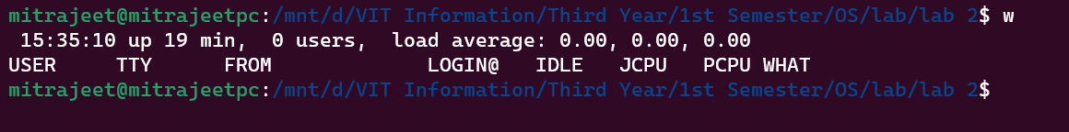

1. Direct the output of the man pages for the date command to a file named *mydate*.



1. Create a subdirectory called *mydir*.



1. Move the file *mydate* into the new subdirectory.



1. Go to the subdirectory *mydir* and copy the file *mydate* to a new file called *ourdate*

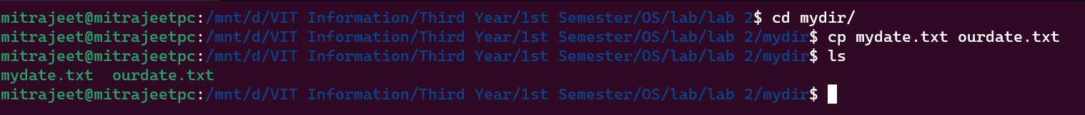

1. List the contents of *mydir*.



1. Do a long listing on the file *ourdate* and note the permissions.



1. Display the name of the current directory starting from the root.



1. Move the files in the directory *mydir* back to the HOME directory.

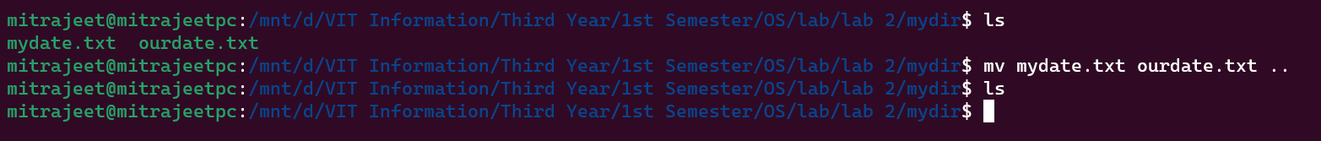

1. List all the files in your HOME directory.



1. Display the first 5 lines of *mydate*.

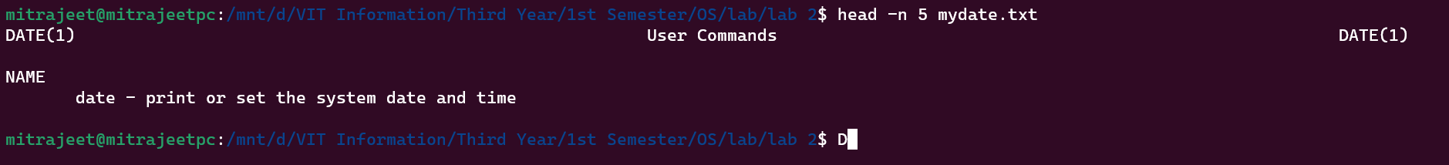

1. Display the last 8 lines of *mydate*.

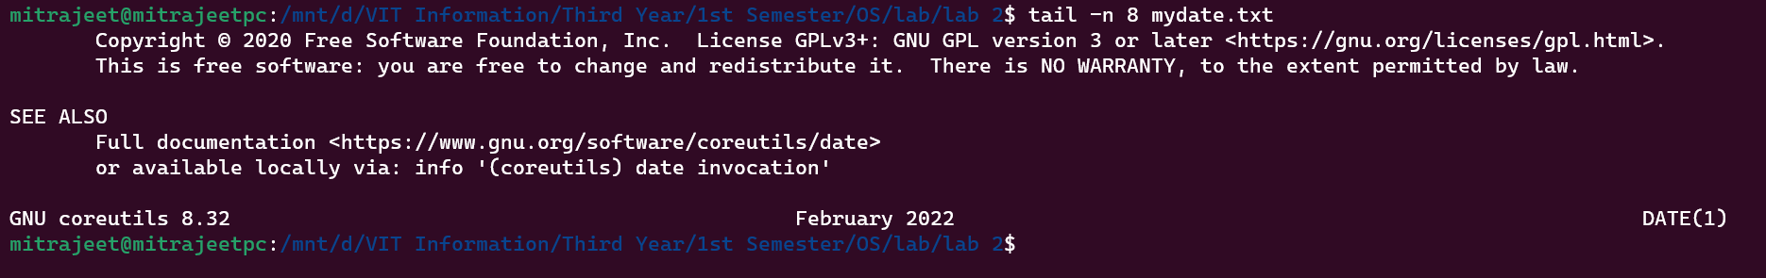

1. Remove the directory *mydir*.



1. Redirect the output of the long listing of files to a file named *list*.



1. Select any 5 capitals of states in India and enter them in a file named *capitals1*. Choose 5 more capitals and enter them in a file named *capitals2*. Choose 5 more capitals and enter them in a file named *capitals3*. Concatenate all 3 files and redirect the output to a file named *capitals*.

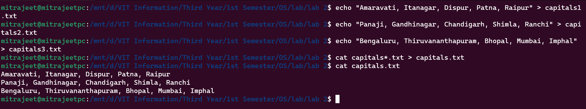

1. Concatenate the file *capitals2* at the end of file *capitals*.

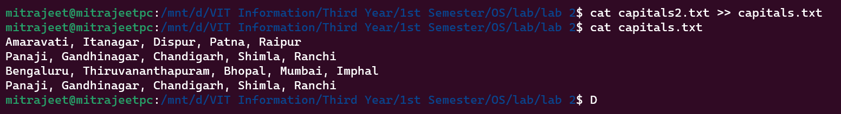

1. Redirect the file *capitals* as an input to the command “wc –l”.



1. Give read and write permissions to all users for the file *capitals*.

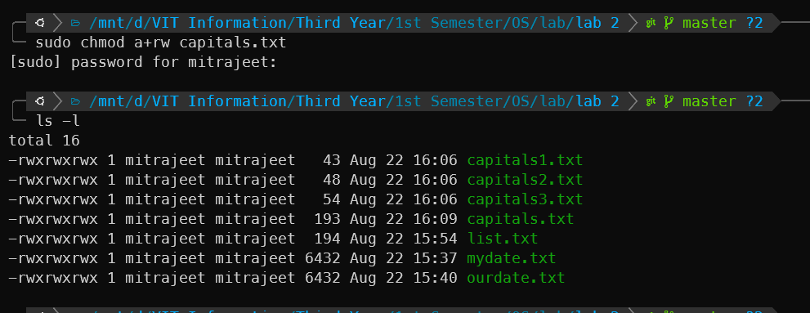

1. Give read permissions only to the owner of the file *capitals*. Open the file, make some changes and try to save it. What happens ?

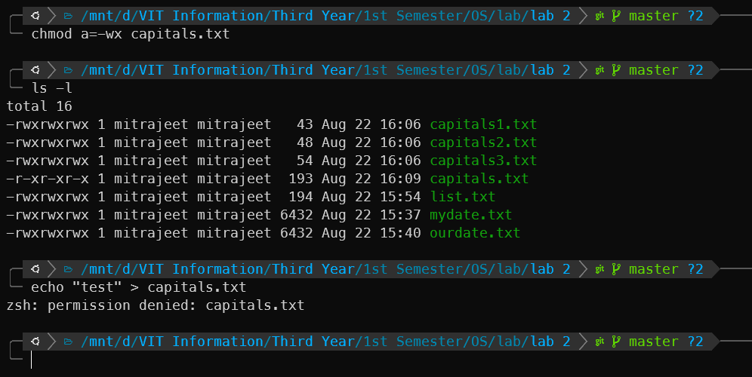

1. Create an alias to concatenate the 3 files *capitals1*, *capitals2*, *capitals3* and redirect the output to a file named *capitals*. Activate the alias and make it run.

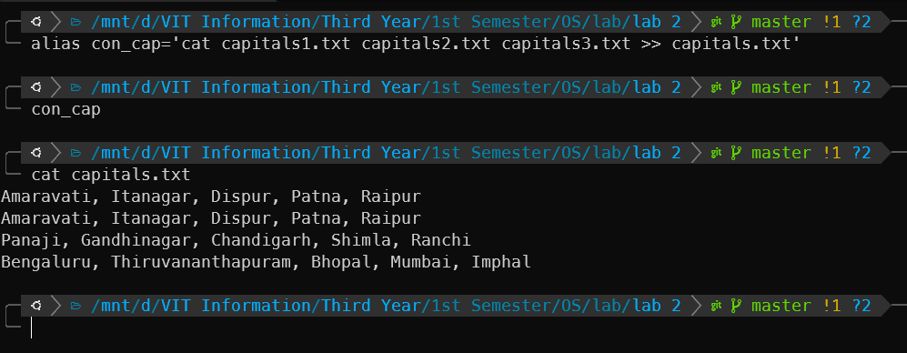

1. What are the environment variables PATH, HOME and TERM set to on your terminal ?

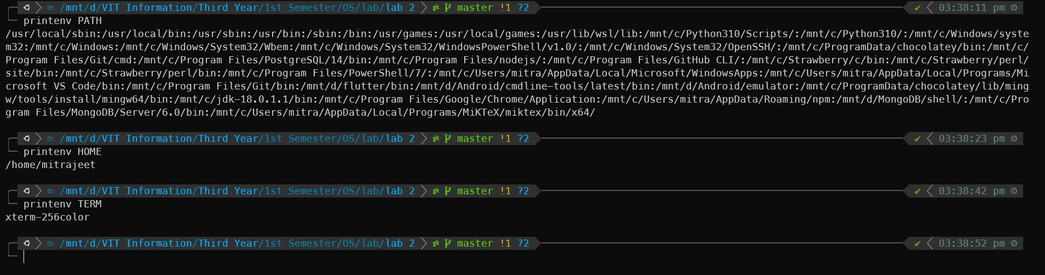

1. Find out the number of times the string “the” appears in the file *mydate*.

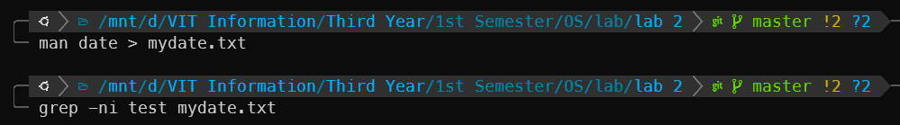

1. List the words of 4 letters from the file mydate.

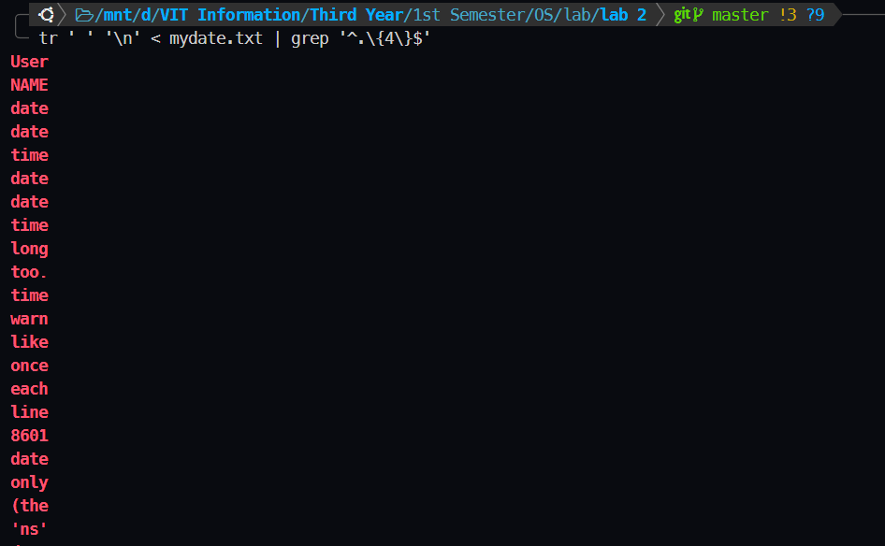

1. List 5 states in north east India in a file mystates. List their corresponding capitals in a file mycapitals. Use the paste command to join the 2 files.

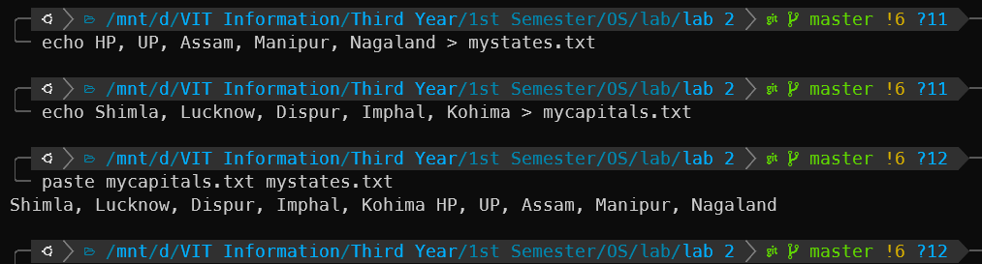

1. Use the cut command to print the 1 st and 3 rd columns of the /etc/passwd file for all students in this class.

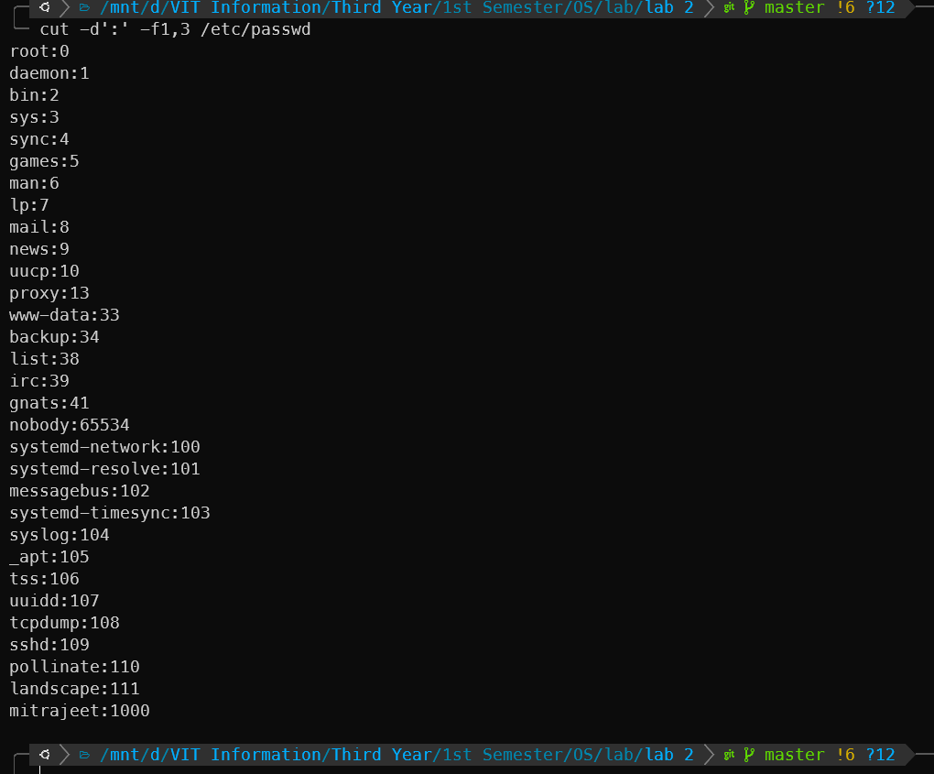

1. Count the number of people logged in and also trap the users in a file using the tee command.

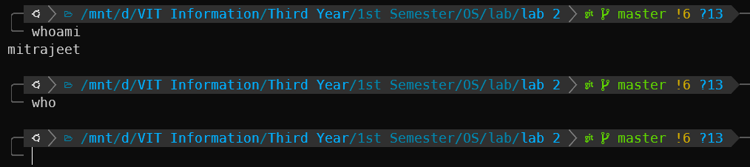

1. Convert the contents of mystates into uppercase.

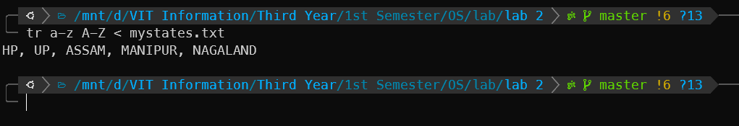

1. Basic Arithmetic – Accept numbers from user

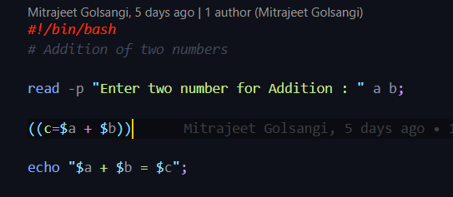

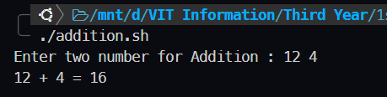

1. Control Structure

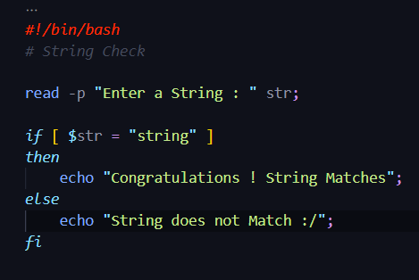

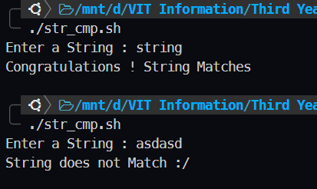

1. Loops

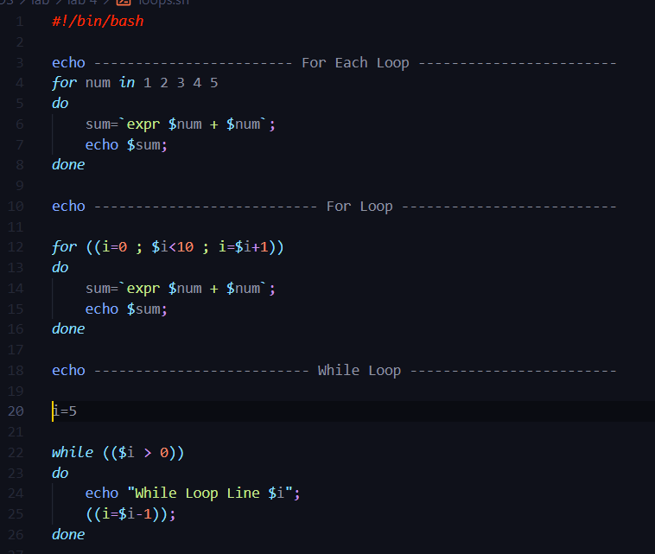

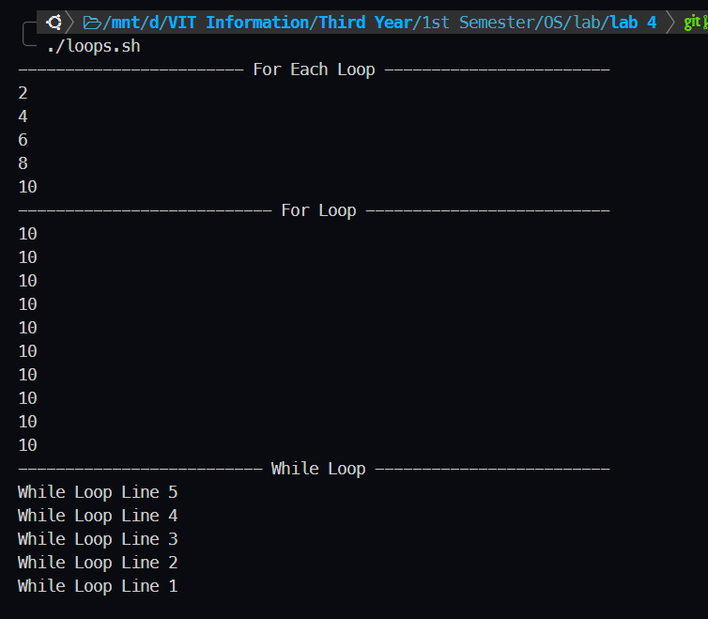

1. Command Line Arguments

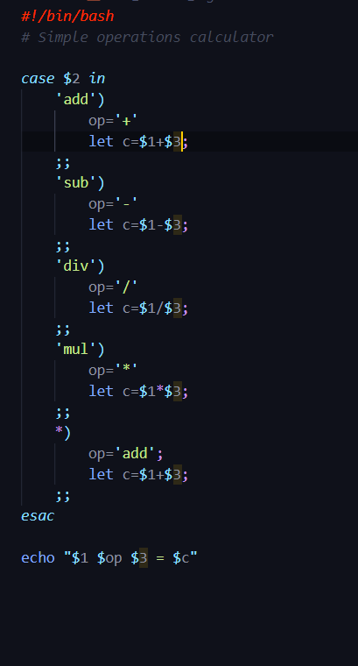

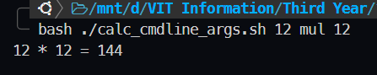

1. Function

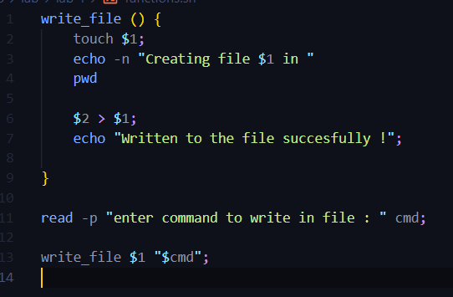

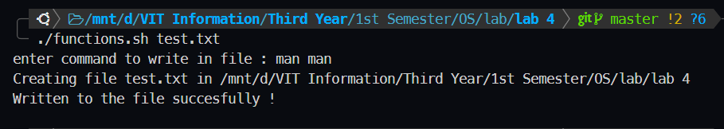

1. Arrays

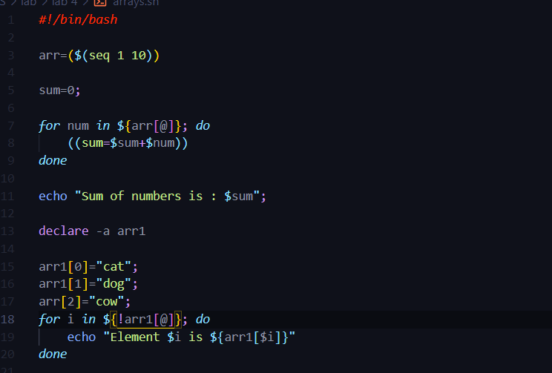

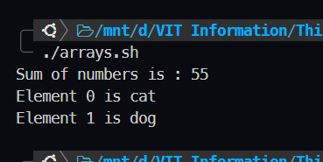

1. String Operations – Length Calc, Print variable as string, string concatenation, String conversion to upper and lower case, Slicing of string, String comparison

